NATIONAL UNIVERSITY OF MODERN LANGUAGE ISLAMABAD
Lab 11


Submitted to:
Sir Hassan Shah
Submitted by:
Zulqarnain Hassan
Roll No: …………………… SP21379
Subject: …………………… computer network
Department: ……………… BSSE-5-Afternoon
Date: ……………………… 13-12-2024

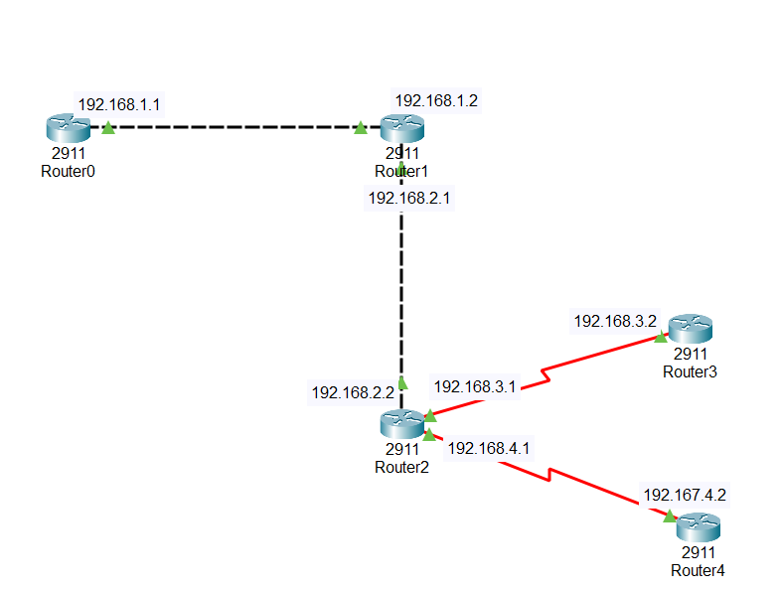

Lab Task of serial connections

Task 1
Router2:

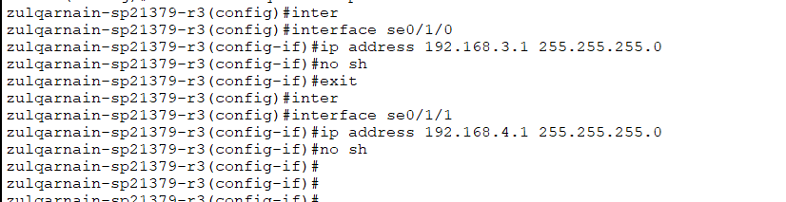

Router3:
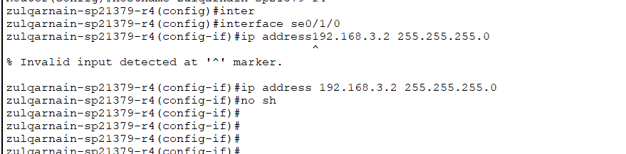

Router4:
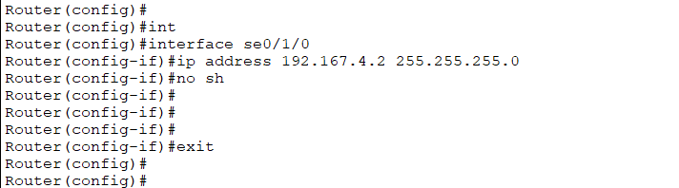

Task 2
Router2:
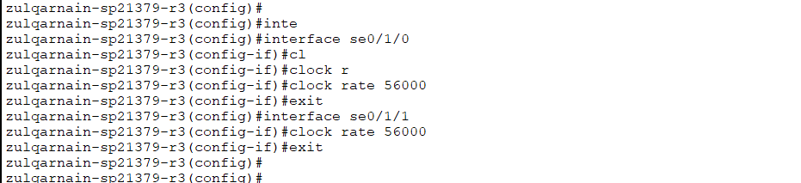

Lab Task of Default Routes
Task 1:
Router0:
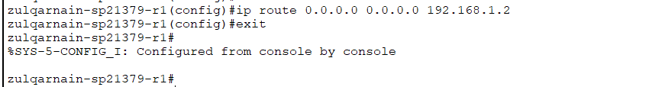
Router1:
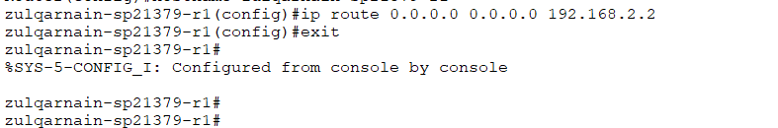
Router2:
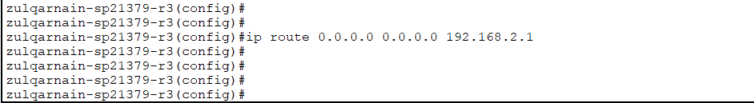
Router3:
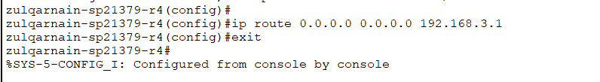
Router4:
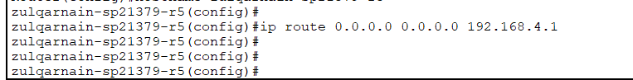
Ping router4 from router0
